|  |  |
| --- | --- |
| **EX NO : 03** | **MULTIPLE WEB PAGES USING EXTERNAL CSS** |
| **DATE :** |

**AIM:**

To design multiple web pages using one external CSS.

**SOFTWARE REQUIRED:**

Visual Studio Code.

**PROCEDURE:**

* Create 3 files with extensions two files having .html and a single .css file.
* To link a external CSS page use link tag within the head tag.
* To create a menu bar use the unordered list tag i.e, ul and li combined with the <a></a> tag..
* Then design the webpage using html and css with the required tags.
* To display video we use <video> and <source> tag.
* For creating a table use <tr>, <th> and <td> tags.
* Now to make the nav bar interactive link the other html files with the <a> tag.
* Repeat the following steps to create the required number of html pages.
* Link all the newly created html files to the same CSS file.
* This allows us to style multiple html webpages to be styled by a single CSS file.

**CSS CODING:**

body, h2, h3, p { margin: 0;

padding: 0;

}

h1{

margin: 0;

padding: 0;

text-align: center;

}

body {

font-family: Arial, sans-serif; background-color:orangered;

}

header {

background-color:black; color: #fff;

padding: 10px 0;

}

nav ul {

list-style-type: none; text-align: center;

}

nav li {

display: inline; margin-right: 20px;

}

nav a {

text-decoration: none; color: #fff;

font-weight: bold;

}

section { padding: 40px;

background-color: #fff; margin: 20px;

border-radius: 5px;

}

.menu-item {

display: inline-block;

width: 30%; margin: 10px;

padding: 10px; text-align: center;

background-color: #f9f9f9; border: 1px solid #ddd; border-radius: 5px;

}

.menu-item img { max-width: 100%; border-radius: 5px;

}

.navbar { overflow: hidden;

background-color: #333;

}

.navbar a { float: left;

font-size: 16px; color: white;

text-align: center; padding: 14px 16px; text-decoration: none;

}

.dropdown { float: center;

overflow: hidden; display: flex;

}

.d1

{

display: flex;

}

.d2

{

vertical-align: top;

}

.dropdown .dropbtn { font-size: 16px; border: none; outline: none;

color: white;

background-color: inherit; font-family: inherit;

font-weight: bold;

margin: 0;

}

.navbar a:hover, .dropdown:hover .dropbtn { background-color: red;

}

.dropdown-content { float: center; display: none; position: absolute;

background-color: #f9f9f9; min-width: 160px;

box-shadow: 0px 8px 16px 0px rgba(0,0,0,0.2); z-index: 1;

margin-left: 2%; margin-top:1%;

}

.dropdown-content a { float: none;

color: black; padding: 12px 16px;

text-decoration: none; display: block;

text-align: left;

}

.dropdown-content a:hover { background-color: #ddd;

}

.dropdown:hover .dropdown-content { display: block;

}

footer {

text-align: center; padding: 10px; background-color: #333; color: #fff;

}

#login {

background-color: #f2f2f2; padding: 40px 0;

text-align: center; width: 40%;

margin-left: 30%;

margin-top: 10%; border-radius: 20px;

}

#login h2 {

margin-bottom: 20px; color: #333;

}

#login form { display: flex;

flex-direction: column;

}

#login .input-container { width: 100%;

margin-left: 3%; margin-bottom: 10px; text-align: left;

}

#login label { display: block; font-weight: bold;

margin-bottom: 5px;

}

#login input { width: 90%; padding: 10px;

border: 1px solid #ccc; border-radius: 5px;

}

#login button { background-color: #333;

width: 40%; color: #fff; border: none;

border-radius: 10px; padding: 10px; cursor: pointer;

font-weight: bold;

margin-top: 2%;

margin-left: 30%;

}

#login button:hover { background-color: #555;

}

#login p {

margin-top: 10px;

}

#login a { color: #333;

text-decoration: none; font-weight: bold;

}

#login a:hover {

text-decoration: underline;

}

**HTML CODING:**

<!DOCTYPE html>

<html lang="en">

<head>

<link rel="stylesheet"type="text/css"href="style.css">

<meta charset="UTF-8">

<meta name="viewport" content="width=device-width, initial-scale=1.0">

<title>Five Star Catering Service</title>

</head>

<body>

<header>

<h1> Welcome To Five Star Catering Service</h1>

</header>

<nav>

<div class="d1">

<div>

<ul>

<li><a href="#about">About Us</a></li>

<li><a href="#menu">Menu</a></li>

</ul>

</div>

<div class="d2">

<ul>

<li>

<div class="dropdown">

<button class="dropbtn">Events

<i class="fa fa-caret-down"></i></button>

<div class="dropdown-content">

<a href="#">Family Dinners</a>

<a href="#">Bridal Showers</a>

<a href="#">Reunions</a>

</div>

</div>

</li>

</div>

<div>

<ul>

<li><a href="#contact">Contact</a></li>

<li><a href="login.html">Login</a></li>

</ul>

</div>

</nav>

<div class="container">

<section id="about">

<h2>About Us</h2>

<p>Welcome to Five Star Catering Service! We provide delicious and customized catering solutions for all your events and occasions.Book with us now and receive a complimentary dessert bar upgrade for your event!

Don't miss the chance to elevate your event to the next level with our catering expertise. Get in touch today, and let's start planning an unforgettable dining experience!</p>

</section>

<section id="menu">

<h2>Menu</h2>

<div class="menu-item">

<img src="catering img.jpg" alt="Dish 1">

<h3>Weddings:</h3><p>Celebrate love with a menu that mirrors your unique story.</p>

<h3>Corporate:</h3><p>Impress clients and colleagues with gourmet offerings.</p>

<h3>Private Parties:</h3><p> Make your special occasions truly unforgettable.</p>

<h3>Any Occasion:</h3><p> We cater to all events, big or small! </p>

</div>

</section>

<section id="contact">

<h2>Contact Us</h2>

<p>For inquiries and bookings, please contact us at:</p>

<address>

Gmail: <a href=["mailto:fivestarcatering](mailto:fivestarcateringservice@gmail.com)s[ervice@gmail.com"](mailto:fivestarcateringservice@gmail.com)>[fivestarcateringservice@gmail.com<](mailto:fivestarcateringservice@gmail.com)/a>

<br>

Phone: <a href="tel:9225689990">9225689990</a>

</address>

</section>

</div>

</body>

</html>

**SNAPSHOT:**

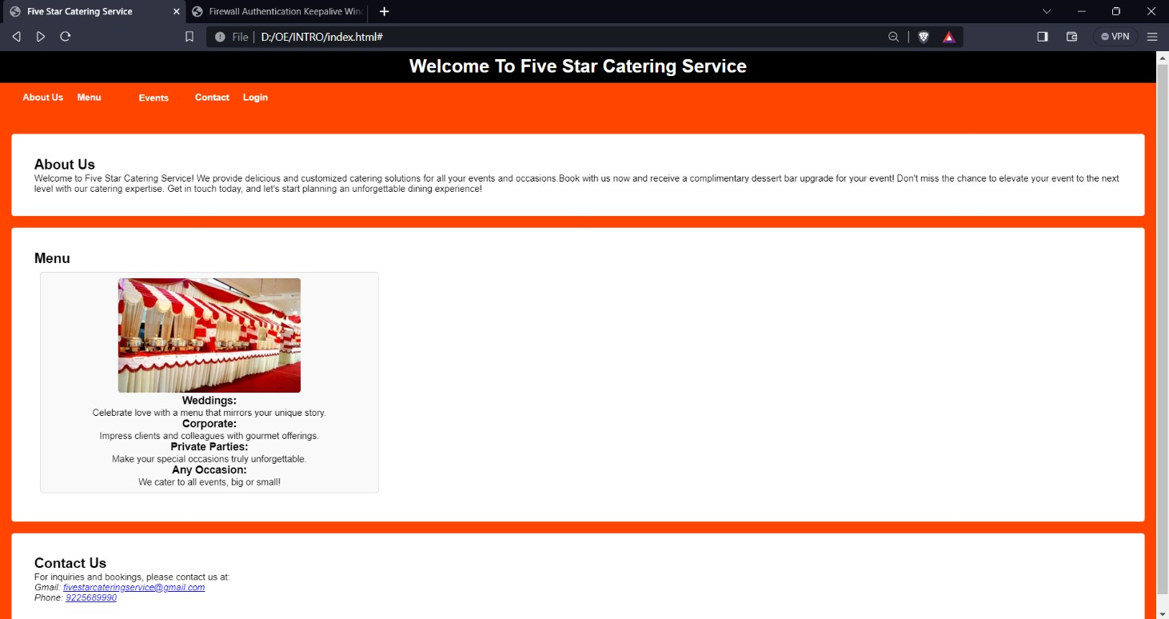

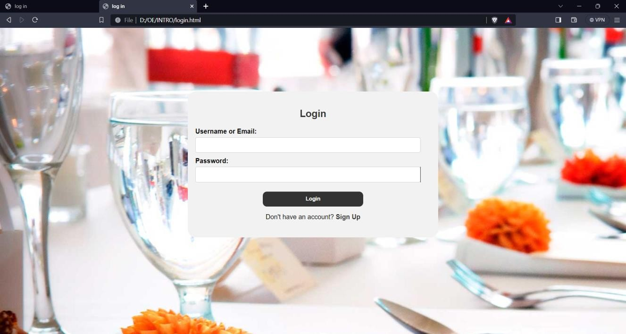

|  |  |
| --- | --- |
| **RUBRICS** | |
| **AIM** |  |
| **ALGORITHM & PROGRAM** |  |
| **OUTPUT & RESULT** |  |
| **VIVA** |  |
| **TOTAL** |  |

**RESULT:**

Thus designing of multiple web pages using external CSS was done successfully.